|  |
| --- |
| **Grocery Shop** |
| **+**ItemName : String  +ItemId : Integer  +quanity : Integerr  +factoryPrice : Double  +shopPrice : Double |
| **+**getItemName(): String  +getItemId(): Integer  + getQuantity(): Integer  +gtFactiryPrice(): Double  +getShopPrice(): Double  +setItemName(): String  +setItemId(): Integer  +setQuantity(): Integer  +setfactoryPrice(): Double  +setShopPrice(): Double |

**CLASS DIAGRAM**

|  |
| --- |
| **GroceryShopTest** |
| itemNameList: ArrayList<groceryshop>  itemIdList: ArrayList<groceryshop>  quantityList: ArrayList<groceryshop>  factoryPriceList: ArrayList<groceryshop>  shopPriceList: ArrayList<groceryshop> |
| **+**inputData(): void  +calculateShopPrice(): void  +displayData(): void  +sellItem(): void  +sortFcatoryPriceItems(): void  +sortByName(): void  +validateName(String): boolean |

**TEST CASES**

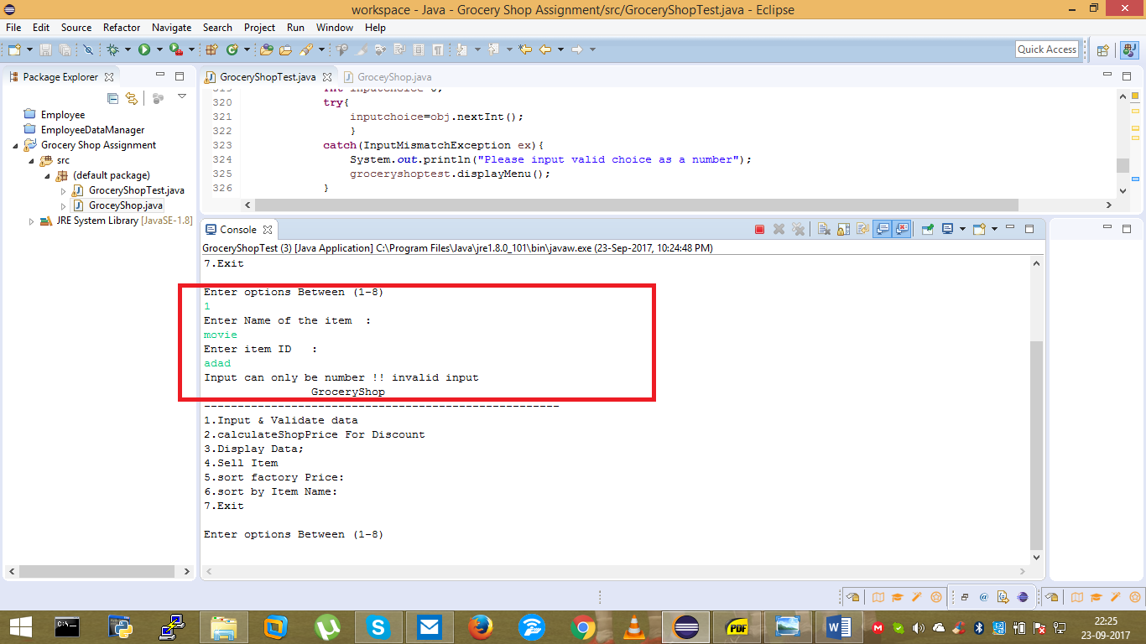

**Screenshot: Testing item ID input exception**

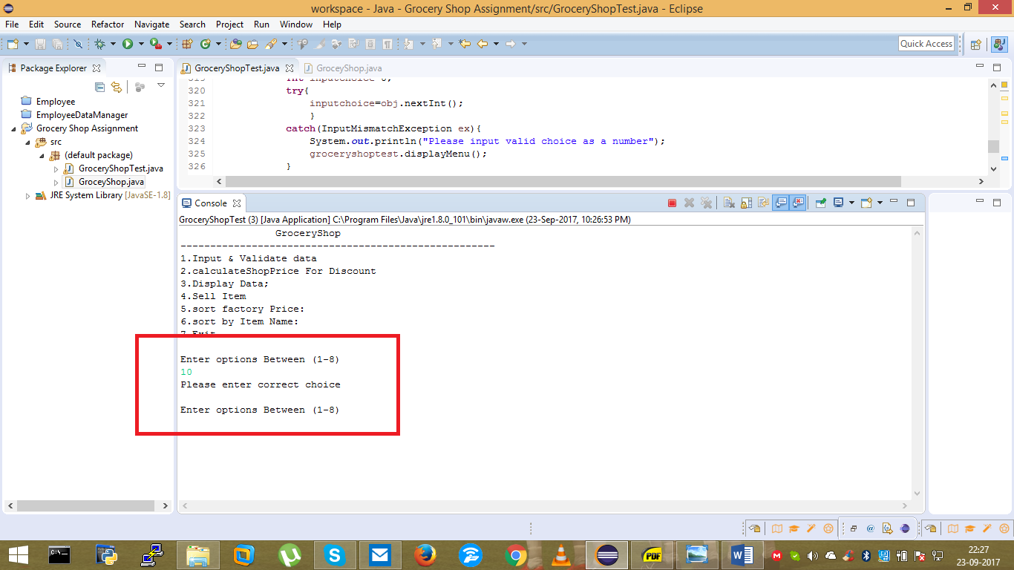

**Screenshot: Validating input choice**

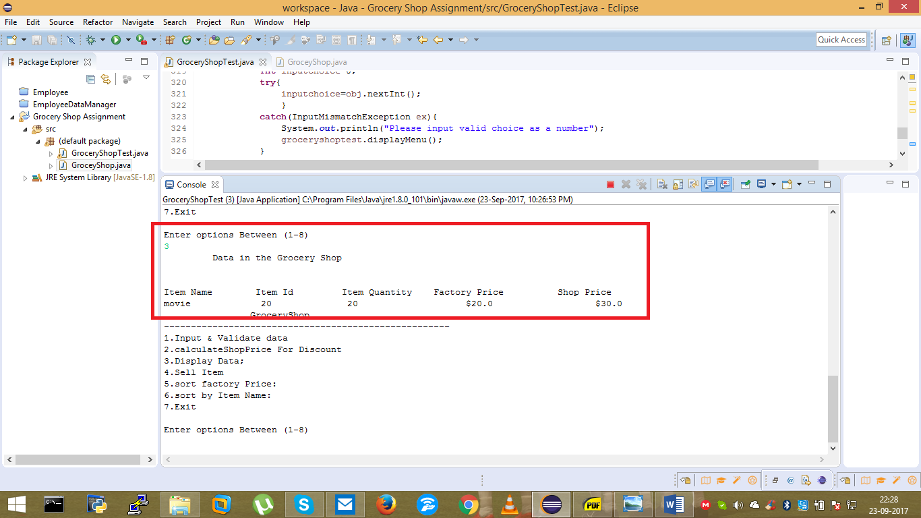

**Screenshot: Display data Functionality**

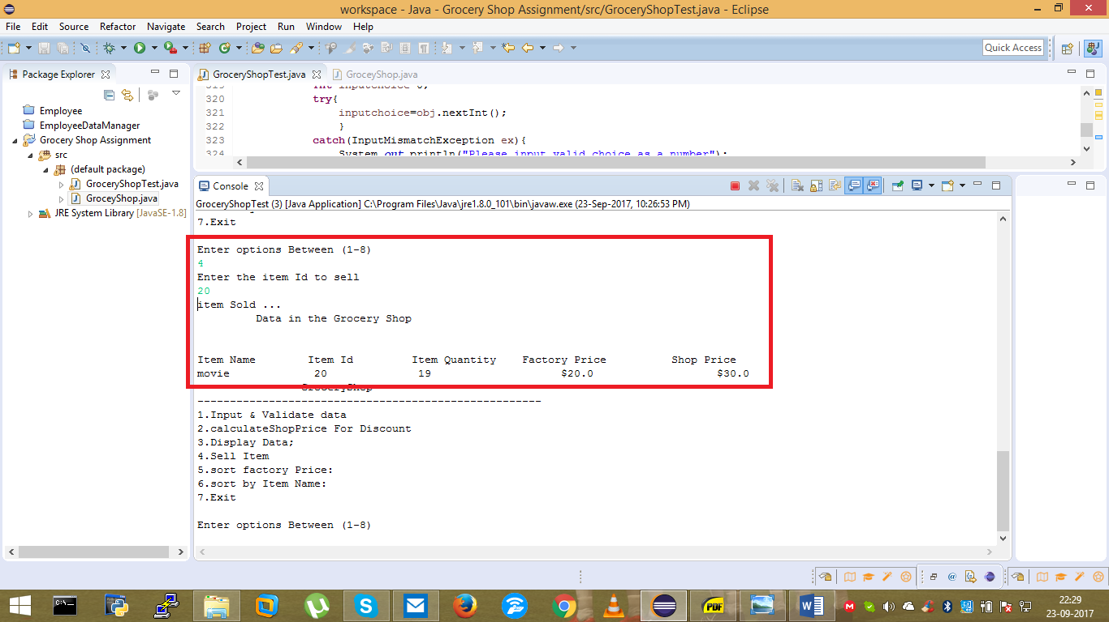

**Screenshot: Sell item Functionality**

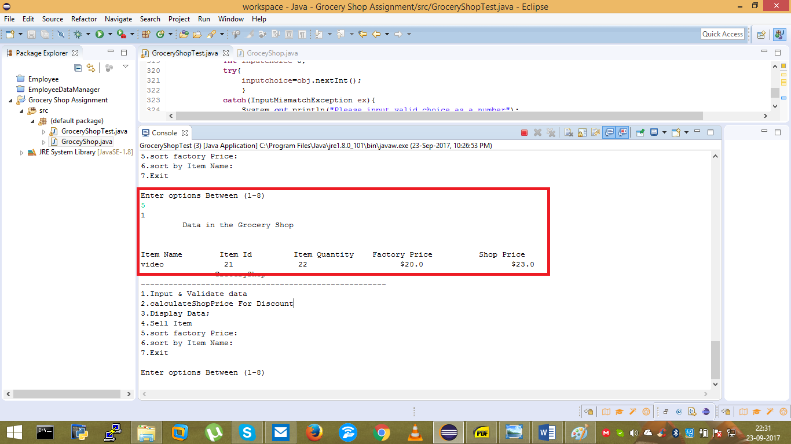

**Screenshot: Sort Factory Price Functionality**

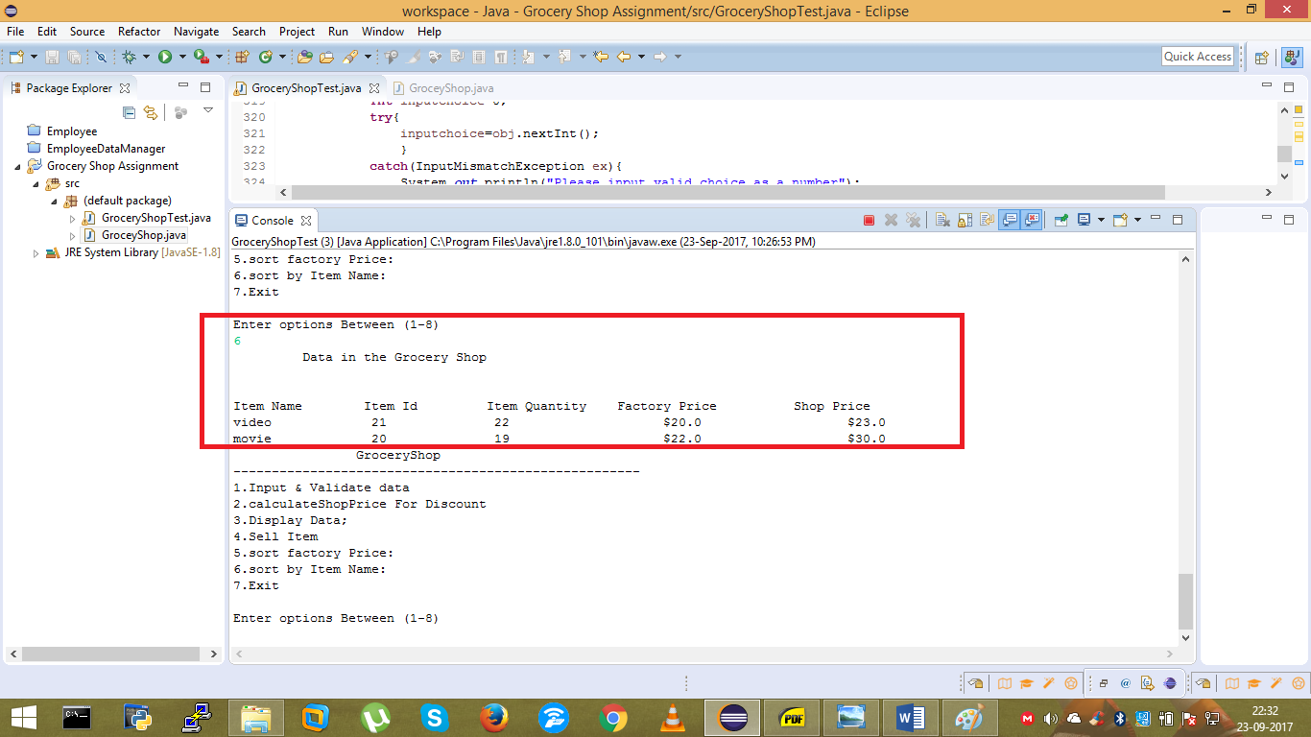

**Screenshot: Sort item Name Functionality**